Project Design Phase-II

Data Flow Diagram & User Stories

|  |
| --- |
| Date 13 October 2022 |
| Team ID - PNT2022TMID17590 |
| Project Name Project -Real Time River Water Quality Monitoring and Control System |
| Maximum Marks 4 Marks |

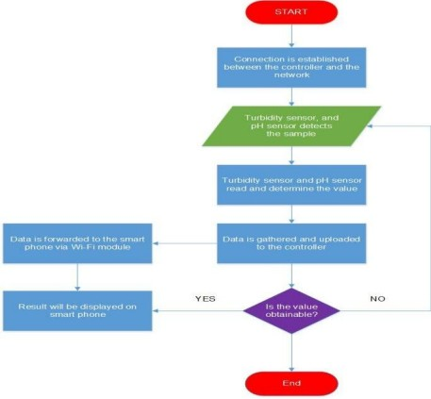**Data Flow Diagram:**

**User Stories**

|  |  |  |  |  |  |
| --- | --- | --- | --- | --- | --- |
| **User Type** | **Functional Requirement (Epic)** | **User**  **User Story / Task**  **Story Number** | **Acceptance criteria** | **Priority** | **Release** |
| Customer (Mobile user) | Registration | USN-1 As a user, I can register for the application by entering email, password, and confirming my password. | I can access my account/dashboard | High | Sprint-1 |
|  |  | USN-2 As a user, I will receive a  confirmation email once I have registered for the  application | I can receive confirmation email & click confirm | High | Sprint-2 |
|  |  | USN-3 As a user, I can register for the  application through Google | I can register & access the dashboard with Google | High | Sprint-1 |
|  |  | USN-4 As a user, I can register for the  application through Gmail | I can register through the mail. | Medium | Sprint-2 |
|  | Login | USN-5 As a user, I can log into the application by entering email, password & captcha | I can receive login credentials. | High | Sprint-1 |
|  | Interface | USN-6 As a user, the interface should be  user-friendly manner | I can able to access easily. | Medium | Sprint-1 |
| Customer (Web user) | dashboard | USN-7 As a user, I can access the specific info (ph. value, temp, humidity, quality). | I can able to know the quality of the water. | High | Sprint-1 |
| Customer (input) |  | USN-8 As a user, I can view data in visual  representation manner(graph) | I can easily understand by visuals. | High | Sprint-1 |
|  | Taste | USN-9 As a user, I can able to view the quality(salty) | I can easily know  whether | High | Sprint-1 |

|  |  |  |  |  |  |
| --- | --- | --- | --- | --- | --- |
|  |  | of the water | it is salty or not |  |  |
|  | Colour visibility | USN-10 As a user, I can ably predict the water colour | I can easily know the condition by colour | High | Sprint-1 |
| Administrator | Risk tolerant | USN-11 An administrator who Is handling the system should update and take care of the application. | Admin should monitor the records properly. | Medium | Sprint-2 |